O’BRIEN INSTITUTE FOR PUBLIC HEALTH

Scientific Director: Dr. Tom Stelfox
Associate Scientific Director (Health Systems): Dr. Kirsten Feist
Associate Scientific Director (Population Health): Dr. Katrina Milaney
Administrative Director: Jamie Day, dayj@ucalgary.ca
Website: https://obrieniph.ucalgary.ca/

The O’Brien Institute’s mission is to advance public health through research excellence, and its four goals are:
- Better Health Care (similar to CIHR Pillar 3, with focus areas of learning health systems and digital health)
- Healthier Populations (similar to CIHR Pillar 4, with focus areas of equity and prevention)
- Thought Leadership (with focus areas of knowledge exchange, innovation, and evidence-informed policy)
- Operational Excellence (with focus areas of increasing capacity for research excellence and public health impact, enhancing the value of membership, and strategic investment)

The Institute’s governance structure includes the leadership team listed above; a team dedicated to communications, events, and administrative support; a Member Operations Committee; a Strategic Advisory Board; and an International Scientific Advisory Group. The O’Brien Institute’s operating budget covers its operational staff and activities; shared research infrastructure; and small awards deemed catalytic to research excellence and societal impact. “Catalyst” funds are awarded to Institute members proposing early phases of well-conceived research projects, post-doctoral funds are awarded to match members’ fellows, and start-up awards are made to support strategic. Additional fund development is under way to extend the Institute’s current annual budget.

The Institute’s membership is comprised of more than 500 population health and health services researchers and research users -- approximately 50% with faculty appointments within the Cumming School of Medicine; 18% in 11 other University of Calgary Faculties; 22% Alberta Health Services employees; the remainder being stakeholders from municipal and provincial government agencies, community service organizations, and other educational institutions. Over 20% of O’Brien members are dual members in one of the 6 other CSM Institutes.

More than 500 trainees and highly qualified personnel are considered ‘affiliates’ and benefit from participating in events and the support programs listed below. The O’Brien Institute does not have an education program per se, but works closely with the Department of Community Health Sciences to optimize the research environment for postdoctoral fellows; graduate students; medical residents; and the Department’s undergraduate students in Medical Education, Bachelor of Health Sciences, and Community Rehabilitation and Disability Studies.

Additional structures within (and beyond) the membership contribute to the Institute’s ecosystem, as illustrated below. Groups within the Institute’s relationship framework advance a broad range of topics relevant to public health, and portfolios led by members of the Member Operations Committee support topic-independent member activities.

University Centres | - Brenda Strafford Centre on Aging  - Centre for Health Policy  - W21C
Research Interest Groups | - Group for Research with Indigenous Peoples (GRIP)  - Health Economics  - Health Geography  - Population Health & Prevention  - Sex, Gender and Women’s Health Research Unit  - Structural and Social Vulnerabilities  - University of Calgary Biostatistics Centre
Alliances (sample) | - AbSPORU (Alberta Strategy for Patient Oriented Research SUPPORT Unit)  - Centre for Health Informatics  - Health Technology Assessment Unit  - Imagine Citizens for Health  - Indigenous, Local and Global Health Office  - Mathison Centre  - One Health  - Office of Health & Medical Education Scholarship
Consortia | - Campus Alberta HOPH  - makeCalgary  - Street CCRED
Member Initiatives (sample) | - Refugee Health YYC  - All our Families  - Chronic Kidney Disease Network (CKDN)  - Interdisciplinary Chronic Disease Collaboration (ICDC)  - Alberta Pregnancy Outcomes and Nutrition (APRON)  - Person to Population Research Collaborative (P2)  - Alberta Provincial Project for Outcome Assessment in Coronary Heart Disease (APPROACH)  - Calgary Critical Care Research Network (CCCRN)

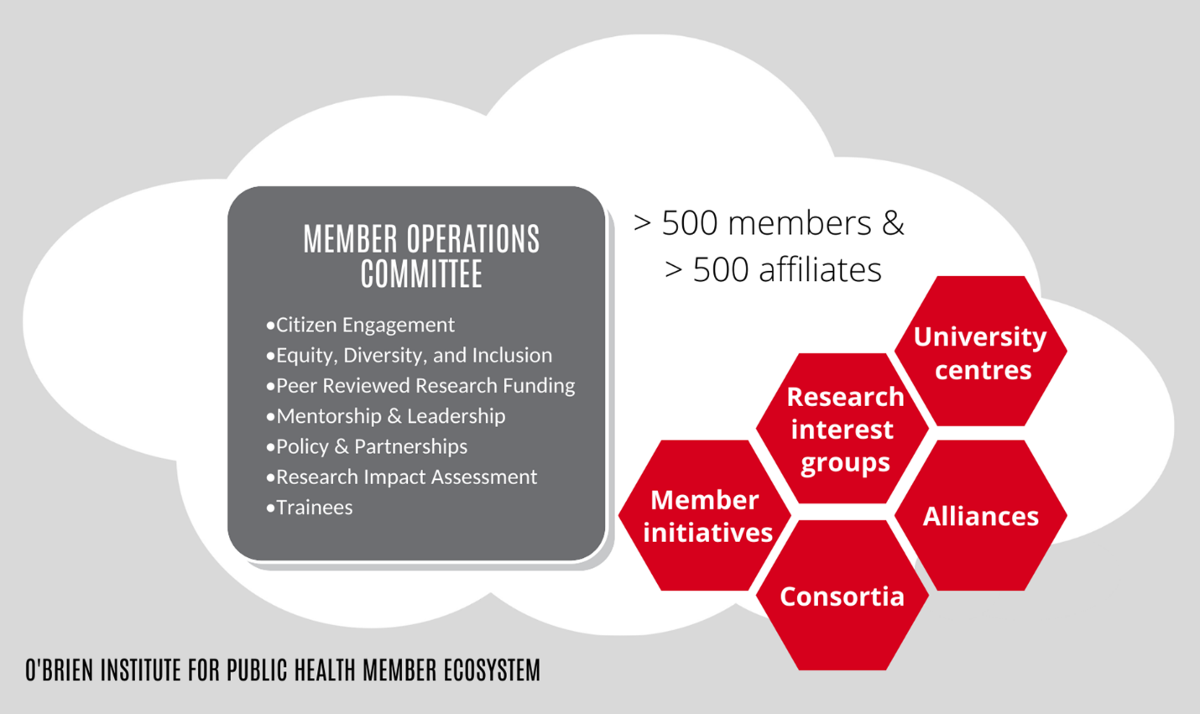

The O’Brien Institute’s support programs and activities facilitate knowledge generation, knowledge exchange, professional development, and networking among the broad membership and stakeholder groups. They include: a seminar series; member forums; various communication tools; special events; and programs for internal peer review, awards and recognition, mentorship and leadership. These assets are often used to inform members of strategies and tactics for success in their research endeavours, from panels on grant writing strategies to research program planning, benefiting from the participation of experienced leaders with relevant expertise.

The internal peer review program is considered particularly effective, contributing to numbers of successful funding applications that consistently match or exceed local and national benchmarks. It can involve: a few relevant experts who participate in an applicant-led operating grant review process; a panel that provides feedback on a member’s new project concepts or career objectives; a bespoke multidisciplinary committee to review all Institute submissions to a particular competition; dedicated meetings with the Institute Review Leads; and other such combinations. In addition to increasing the quality of submitted applications, the internal peer review program is credited with stimulating valuable networking among the membership. The collegial environment that enables this and other Institute support programs has been much lauded by external reviewers.

Societal impact is one half of the O’Brien Institute’s mission, and the desired result of the other half (academic excellence). Sophisticated knowledge exchange and partnership building are required elements of achieving benefits to society, and the Institute has designed its governance structure and human resources to attain this goal. In addition to linking knowledge generators and knowledge end-users within the membership, the Institute is increasingly successful in brokering external relationships with provincial and national interest groups, policy makers, funding agencies, the media, philanthropists, and community stakeholders, thereby extending the reach and impact of its members’ significant research outputs.

Shared infrastructure for population health and health services research is also made available through the O’Brien Institute. The 3rd floor of the Cumming School of Medicine’s TRW Building comprises office space for faculty members in the Department of Community Health Sciences, and workstations for research staff and Institute employees. As the physical hub for the Institute, TRW 3rd floor has several conference rooms designed for in-person and virtual meetings, computer stations hosting relevant software, drop-in desks for students, and drop-in offices for visiting faculty. The W21C program, located on the 1st floor of the TRW, manages health systems research space, including patient and provider simulations.

